 | 7.2.20 Editors - 3D Viewport - Tool Shelf - Curve - Edit Mode
Table of content
Tool Shelf - Hair Curve - Edit Mode 2
Tweak, Select, Transform, 3D Cursor Measure and Annotate tools 2
Draw 2
Tool Settings 2
Type 2
Method 3
Refit 3
Split 3
Tolerance 3
Detect Corners 3
Taper Start / End 3
Radius Min/Max 3
Use Pressure 3
Depth 3
Cursor 3
Surface 3
Absolute Offset 3
Only First 3
Plane 3
Normal to Surface 3
Tangent to Surface 4
View 4
Last Operator Draw Curves 4
Error 4
Fit Method 4
Corner Angle 4
Cyclic 4
Radius 4
Header Value 4
Tool Settings 4
Drag 5
Active Tool 5
Tweak, Select Box, Circle and Lasso 5
Last Operator Transform 5
Values X Y Z W 5
Axis 5
Orientation 5
Proportional editing 5
Proportional Falloff 5
Proportional Size 5
Connected 5
Projected(2D) 5
Tilt 6
Header Value 6
Tool Settings 6
Drag 6
Active Tool 6
Tweak, Select Box, Circle and Lasso 6
Last Operator Transform 6
Angle 6
Proportional editing 6
Proportional Falloff 6
Proportional Size 6
Connected 6
Projected(2D) 7

Tool Shelf - Hair Curve - Edit Mode
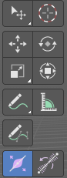
With a hair curve object in edit mode you will find some tools to edit the curve geometry in the tool shelf.

Tweak, Select, Transform, 3D Cursor Measure and Annotate tools

The tweak, select, transform, 3d cursor, measure and annotate tools at the end of the list are explained in the chapter 7.1.1 Editors - 3D View - Tool Shelf - Object Mode. We won't cover this tools again here.

Draw
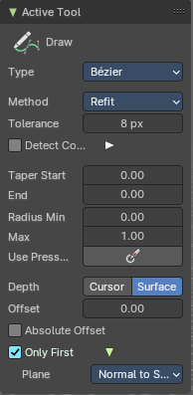
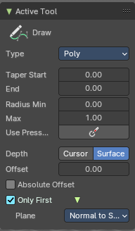
Allows you to draw a curve into the viewport.

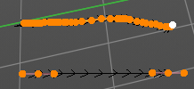

Tool Settings

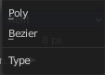
Type
Set the draw method for the curve. Poly draws a simple polygon shape. Bezier creates a Bezier curve type with handlers.
With type Bezier you will get more options.

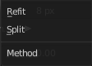
Method
The curve fitting method for a Bezier curve.

Refit
Incrementally refit the curve.

Split
Split the curve until it fits.

Tolerance
Allow deviation for a smoother but less precise line.

Detect Corners
Detect corners and use non aligned angles.

Taper Start / End
Taper factor for the radius of each curve point.

Radius Min/Max
Minimum or maximum radius when the pressure is applied.

Use Pressure
Use tablet pressure to draw the curve.

Depth
The method of projecting depth. Cursor or surface.

Cursor
Cursor has no further settings.

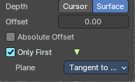
Surface

Absolute Offset
Apply a fixed offset, and don't scale by the radius.

Only First
Use the start of the stroke for the depth.

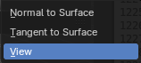
Plane
The plane for the projected strokes.

Normal to Surface
Draw in a plane perpendicular to the surface.

Tangent to Surface
Draw in the surface plane.

View
Draw in a plane that is aligned to the viewport.

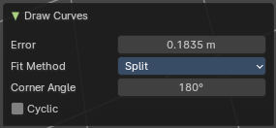
Last Operator Draw Curves

Error
Adjust the error distance threshold in object units

Fit Method
The curve fitting method. Choose between Refit and Split.

Corner Angle
Corners above this angle are considered as corners.

Cyclic
With curve type Bezier the curve gets closed. Has no effect at curve type Poly.

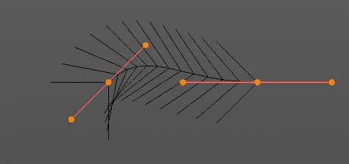
Radius
Bezier curves have a radius. This is displayed by the black lines that points away from the curve. The radius tool allows you to resize this radius.

Header Value
When you resize the curve radius then you will see a value in the header. It tells you the current scale factor. This factor always starts with 1.

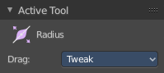
Tool Settings

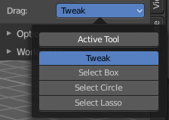
Drag
When you click at the widget of the active tool, then you perform the tool action. Adjust what should happen when you click outside of the widget, in the empty area.

Active Tool
When you click off the widget then the click still does the same than clicking at the widget. It performs the active tool.

Tweak, Select Box, Circle and Lasso
When you choose this options then you will set the off click to the different select methods. Whereas tweak works more than a move tool then. Tweak is the default.

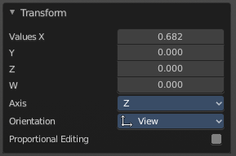
Last Operator Transform

Values X Y Z W
The axis to increase the radius. Just X has an effect with the curve radius.

Axis
The axis to use. This has no effect with a curve object.


Orientation
Adjust the orientation of the extrusion. It usually starts with Normal.

Proportional editing
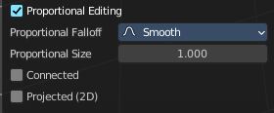
Enables proportional editing. Activating proportional editing reveals further settings.

Proportional Falloff
Adjust the falloff methods.

Proportional Size
See and adjust the falloff radius.

Connected
The proportional falloff gets calculated for connected parts only.

Projected(2D)
The proportional falloff gets calculated in the screen space. Depth doesn't play a role. When it's in the radius, then it gets calculated.

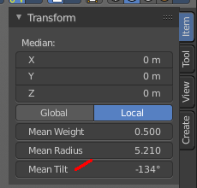
Tilt
With this tool you can tilt the curve. It is the mean tilt value in the Transform panel of the Sidebar.

Header Value
When you rotate the curve with the tilt tool, then you will see a value in the header. It tells you the current rotation relative to the starting rotation. This value always starts with 0.

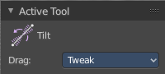
Tool Settings

Drag
When you click at the widget of the active tool, then you perform the tool action. Adjust what should happen when you click outside of the widget, in the empty area.

Active Tool
When you click off the widget then the click still does the same than clicking at the widget. It performs the active tool.

Tweak, Select Box, Circle and Lasso
When you choose this options then you will set the off click to the different select methods. Whereas tweak works more than a move tool then. Tweak is the default.

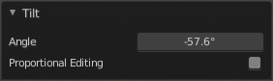
Last Operator Transform

Angle
This value tells you the current rotation relative to the starting rotation. This value always starts with 0.

Proportional editing
Enables proportional editing. Activating proportional editing reveals further settings.

Proportional Falloff
Adjust the falloff methods.

Proportional Size
See and adjust the falloff radius.

Connected
The proportional falloff gets calculated for connected parts only.

Projected(2D)
The proportional falloff gets calculated in the screen space. Depth doesn't play a role. When it's in the radius, then it gets calculated.

